**Coulomb's Law**

**Pre-lab questions**

1. What is the goal of this experiment? What physics and general science concepts does this activity demonstrate to the student?
2. What is a torsion balance?
3. Suppose two identical electric charges experience a Coulomb force *F*1. Now, one of the electric charges is doubled in magnitude. What can you say about the Coulomb force between them now?

The goal of this experiment is to semi-quantitatively investigate the force between electric charges. What is the nature of the force? What causes the magnitude of the force to change?

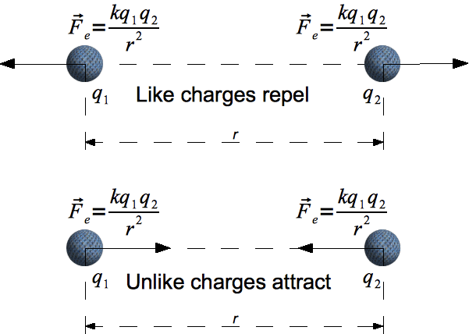**Introduction**

Electric charge is a fundamental property of protons and electrons, as well as other subatomic particles. It is conserved, electric charge may be moved from place to place but net electric charge is not created or destroyed. As observed freely in nature, electric charge comes in discrete amounts corresponding to the quantity of charge on an electron, *e* ≈ -1.602×10-19 C. And electric charge is observed in two polarities, called positive and negative.

The force between a pair of electric charges, known as the Coulomb force, varies directly with the magnitude of the charges and inversely with the square of the distance between them. $F_{e}={(kq_{1}q_{2}}/{r^{2})}\hat{r}$. The strength of the Coulomb force is indicated by the multiplicative Coulomb constant in Coulomb’s law: *k* = 1/(4*πϵ*0) ≈ 8.99×109 N·m2/C2.

Figure 1: Coulomb's Law for electric charges

The electric force is one of the strongest in nature. If you took one gram of protons and placed them one meter away from one gram of electrons, the force between them would be about 1.5×1023 Newtons. This is roughly the force it would take to "lift" an object from the surface of the Earth that had a mass about 1/5 that of the moon. This strength of interaction makes it difficult to keep opposite charges away from each other, or to keep like charges near each other. Atoms are mostly neutral because of the attraction between opposite charges, and it takes an even stronger force – the strong nuclear force – to keep the protons in the nucleus close together.

Relatively small amounts of isolated electric charge are used in the laboratory. These small quantities require the use of a sensitive balance to measure the low level of force.

**Equipment**

Coulomb’s law apparatus with torsion balance, high voltage power supply.

**Experiment Introduction**

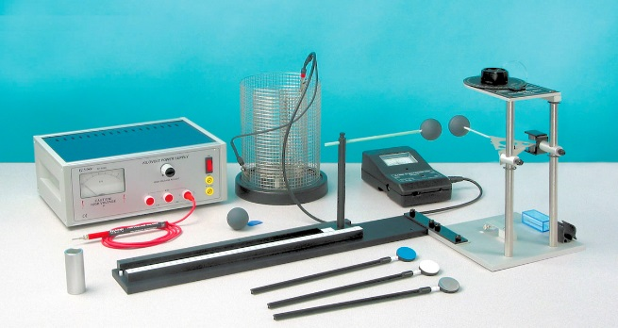

The Coulomb Balance (Figure 2) is a delicate torsion balance that can be used to investigate the force between charged objects. A conductive sphere is mounted on a rod, counterbalanced, and suspended from a thin torsion wire. An identical sphere is mounted on a slide assembly so it can be positioned at various distances from the suspended sphere.

Figure 2: Coulomb balance equipment

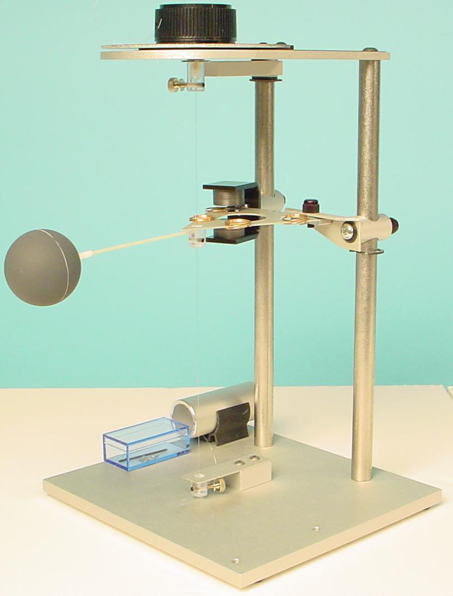To perform the experiment, both spheres are charged, and the sphere on the slide assembly is placed at fixed distances from the equilibrium position of the suspended sphere. The electrostatic force between the spheres causes the torsion wire to twist. The experimenter then twists the torsion wire to bring the balance back to its equilibrium position. The angle through which the torsion wire must be twisted to reestablish equilibrium is directly proportional to the electrostatic force between the spheres. All the variables of the Coulomb relationship $(F_{e}={kq_{1}q_{2}}/{r^{2})}$ can be varied and measured using the Coulomb Balance. The experimenter can verify the inverse square relationship and the charge dependence using the balance and any electrostatic charging source.

Figure 3: Setting up the Coulomb balance

**Set Up**

1. Adjust the position of the copper rings on the counterweight vane so the pendulum assembly is level.
2. Reposition the index arm so it is parallel with the base of the torsion balance and at the same height as the vane.
3. Adjust the height of the magnetic damping arm so the counterweight vane is midway between the magnets.
4. Turn the torsion knob until the index line on the counterweight vane aligns with the index line on the index arm. Note the zero offset on the torsion knob.
5. *Connect the slide assembly* to the torsion balance as shown in Figure 4, using the coupling plate and thumbscrews to secure it in position.
6. *Align the spheres vertically* by adjusting the height of the pendulum assembly so the spheres are aligned: Use the supplied allen wrench to loosen the screw that anchors the pendulum assembly to the torsion wire. Adjust the height of the pendulum assembly as needed.
7. Readjust the height of the index arm and the magnetic damping arm as needed to reestablish a horizontal relationship.
8. *Align the spheres laterally* by loosening the screw in the bottom of the slide assembly that anchors the vertical support rod for the sphere, using the supplied allen wrench (the vertical support rod must be moved to the end of the slide assembly, touching the white plastic knob to access the screw). Move the sphere on the vertical rod until it is laterally aligned with the suspended sphere and tighten the anchoring screw.
9. *Position the slide arm* so that the centimeter scale reads 3.8 cm (this distance is equal to the diameter of the spheres).
10. *Position the spheres* by loosening the thumbscrew on top of the rod that supports the sliding sphere and sliding the horizontal support rod through the hole in the vertical support rod until the two spheres just touch. Tighten the thumbscrew.

At this point the experiment is ready. The degree scale should read zero, the torsion balance should be zeroed (the index lines should be aligned), the spheres should be just touching, and the centimeter scale on the slide assembly should read 3.8 cm. (This means that the reading of the

centimeter scale accurately reflects the distance between the centers of the two spheres.)

**PROCEDURE - FORCE VS. DISTANCE (PART A)**

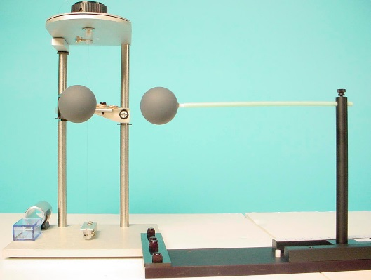

1. Be sure the spheres are fully discharged (touch them with a grounded probe) and move the sliding sphere as far as possible from the suspended sphere. Set the torsion dial to 0 degrees. Zero the torsion balance by appropriately rotating the bottom torsion wire retainer until the pendulum assembly is at its zero displacement position as indicated by the index marks.

**Figure 5: Experimental Setup**

1. With the spheres still at maximum separation, charge both the spheres to a potential of 6 kV, using the charging probe. (One terminal of the power supply should be grounded.) Immediately after charging the spheres, turn the power supply off to avoid high voltage leakage effects.
2. Position the sliding sphere at a position of 20 cm. Adjust the torsion knob as necessary to balance the forces and bring the pendulum back to the zero position.
3. Separate the spheres to their maximum separation, recharge them to the same voltage, then reposition the sliding sphere at a separation of 20 cm. Measure the torsion angle and record your results again. Repeat this measurement several times, until your result is repeatable to within ± 1 degree.
4. Record the distance (R) and the angle () in the Data Table "Twist Angle v Distance" that you have created for your lab report.
5. Repeat steps 1-5 for 14, 10, 9, 8, 7, 6 and 5 cm.

**ANALYSIS OF PART A**

1. Calculate the inverse square of the distance values and enter them into the Data Table "Twist Angle v 1/R2 that you have created.
2. Create a graph from this data. Note any anomalies in the data since we are assuming two point charges instead of two spheres.
3. Determine the functional relationship between force (which is proportional to the torsion angle ()) and the distance (R).

**PROCEDURE – FORCE VS. DISTANCE (PART B)**

1. Be sure the spheres are fully discharged (touch them with a grounded probe) and move the sliding sphere as far as possible from the suspended sphere. Set the torsion dial to 0 degrees. Zero the torsion balance by appropriately rotating the bottom torsion wire retainer until the pendulum assembly is at its zero displacement position as indicated by the index marks.
2. With the spheres still at maximum separation, charge both the spheres to a potential of 3 kV, using the charging probe. (One terminal of the power supply should be grounded.) Immediately after charging the spheres, turn the power supply off to avoid high voltage leakage effects.
3. Position the sliding sphere at a position of 10 cm. Adjust the torsion knob as necessary to balance the forces and bring the pendulum back to the zero position.
4. Record the Voltage (kV) and the angle () in the Data Table "Twist Angle v Voltage" which you have created.

**ANALYSIS OF PART B**

1. Create a graph from this data. Note any anomalies in the data since we are assuming two point charges instead of two spheres.
2. Determine the functional relationship between force (which is proportional to the torsion angle ($θ$)) and the charge (q) (which is proportional to the Voltage).

**PROCEDURE – THE COULOMB CONSTANT (PART C)**

In parts A and B of this lab, you determined (if all went well) that the electrostatic force between two point charges is inversely proportional to the square of the distance between the charges and directly proportional to the charge on each sphere. This relationship is stated mathematically in Coulomb's Law:



where F is the electrostatic force, q1 and q2 are the charges, and R is the distance between the charges. In order to complete the equation, you need to determine the value of the Coulomb constant, k. To accomplish this, you must measure three additional variables: the torsion constant of the torsion wire (Ktor), so you can convert your torsion angles into measurements of force, and the charges, q1 and q2. Then, knowing F, q1, q2, and R, you can plug these values into the Coulomb equation to determine k.

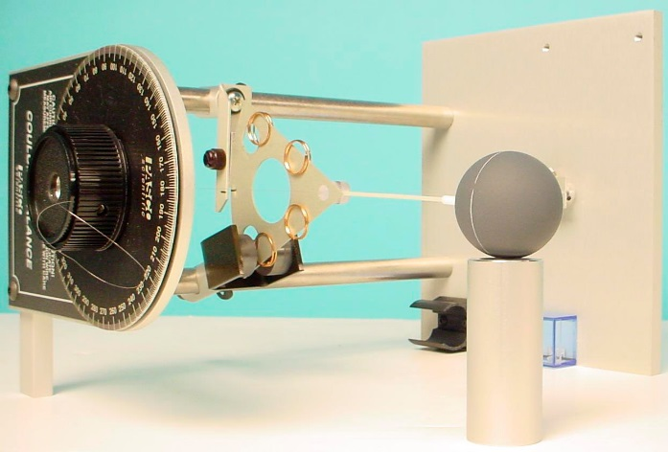**Measuring the Torsion constant, Ktor**

**Figure 6. Calibrating the Torsion Balance**

1. Carefully turn the Torsion Balance on its side, supporting it with the lateral support bar, as shown in Figure 6. Place the support tube under the sphere, as shown.
2. Zero the torsion balance by rotating the torsion dial until the index lines are aligned.
3. 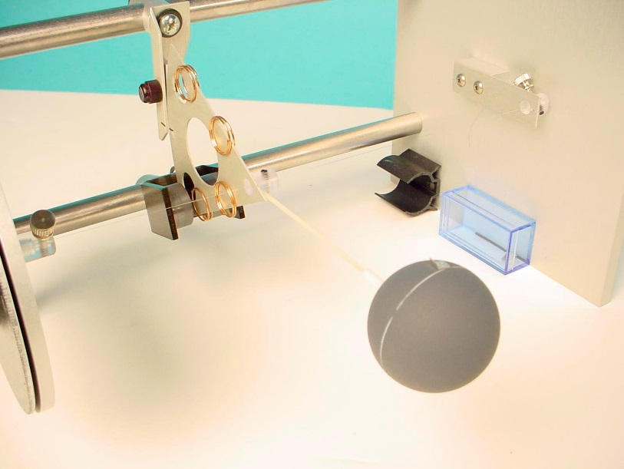Record the angle of the degree plate in the Data Table "Mass(mg) v Twist Angle" in the table you have created.

**Figure 7. Placing the Mass on the Sphere**

1. Carefully place the 20 mg mass on the center line of the conductive sphere.
2. Turn the degree knob as required to bring the index lines back into alignment. Read the torsion angle on the degree scale.
3. Record the angle in the Data Table "Mass (mg) v Twist Angle."
4. Repeat the previous steps, using the two 20 mg masses and the 50 mg mass to apply each of the masses shown in the table. Each time record the mass and the torsion angle.
5. Convert the values of mass in mg to Newtons. Enter these values along with the corresponding angles in the Data Table "Weight v Twist Angle."
6. Determine the value of the Torsion constant, Ktor from the graph of "Weight v Twist Angle."

**Finding the Charge**

Fig 8 measuring charge with electrometer

**Figure 8. Measuring the Charge with an Electrometer and a Faraday Ice Pail**

The charge on the spheres can be measured more accurately using an electrometer with a Faraday ice pail. The setup for the measurement is shown in Figure 8. The electrometer and ice pail can be modeled as an infinite impedance voltmeter in parallel with a capacitor. A sphere with a charge q is touched against the ice pail. Since the capacitance of the ice pail and electrometer is much greater than that of the sphere, virtually all of the charge q is transferred onto the ice pail. The relationship between the voltage reading of the electrometer and the charge deposited into the system is given by the equation q = CV, where C is the combined capacitance of the electrometer, the ice pail, and the connecting leads. Therefore, in order to determine the charge, you must know the capacitance of the system.

**Finding the Capacitance of the System**

1. First find the capacitance of the ice pail and the connecting leads. Attach the alligator clips to the ice pail. Use a capacitor meter to measure the capacitance by placing one lead of the capacitor meter to the inside of the coaxial cable and the other to the outside.
2. Add this value to the capacitance of the electrometer. The PASCO Basic Electrometer maintains a capacitance of 30 pF. Record this value.

**Measuring the Charges q1 and q2**

1. Hang the third sphere from a horizontally mounted rod. At this point make certain that the sphere is not in contact with anything.
2. Carefully charge the “sliding” sphere with the same voltage as in Part A (6.0 kV). Since only one sphere is used, this charge is half the charge of the spheres from that section of this experiment.
3. Transfer the charge to the hanging sphere by touching the “sliding” sphere to the hanging sphere.
4. Place the hanging sphere in the middle of the ice pail in contact with the inside section.
5. Making sure it is grounded, connect the electrometer leads to the ice pail. Record the value of the voltage.
6. Calculate the charge on one sphere using the equation:

q = CV

Remember that since this is half the charge, it must be multiplied by two. Remember, as well, that this charge value represents just one of the spheres.

**Calculating Coulomb’s Constant (k)**

1. Choose a data point from the “Twist Angle v Distance” graph of Part A.

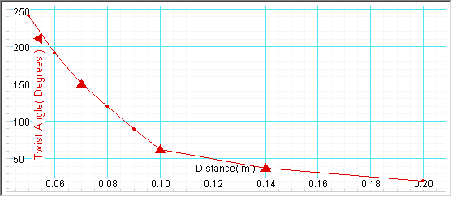

1. Use the torsion constant to convert the twist angle to Newton force units.

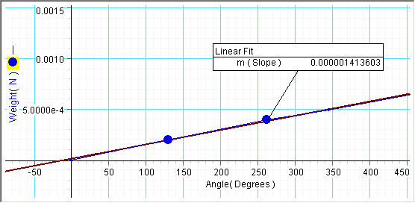

1. Use this force value (F), the accompanying distance value (R), and the charge value to calculate the Coulomb Constant (k):



1. Calculate the Coulomb Constant with several other data points. Find the average.

**QUESTION**

1. Compare your experimental value with the accepted value of Coulomb’s Constant 8.99x109 